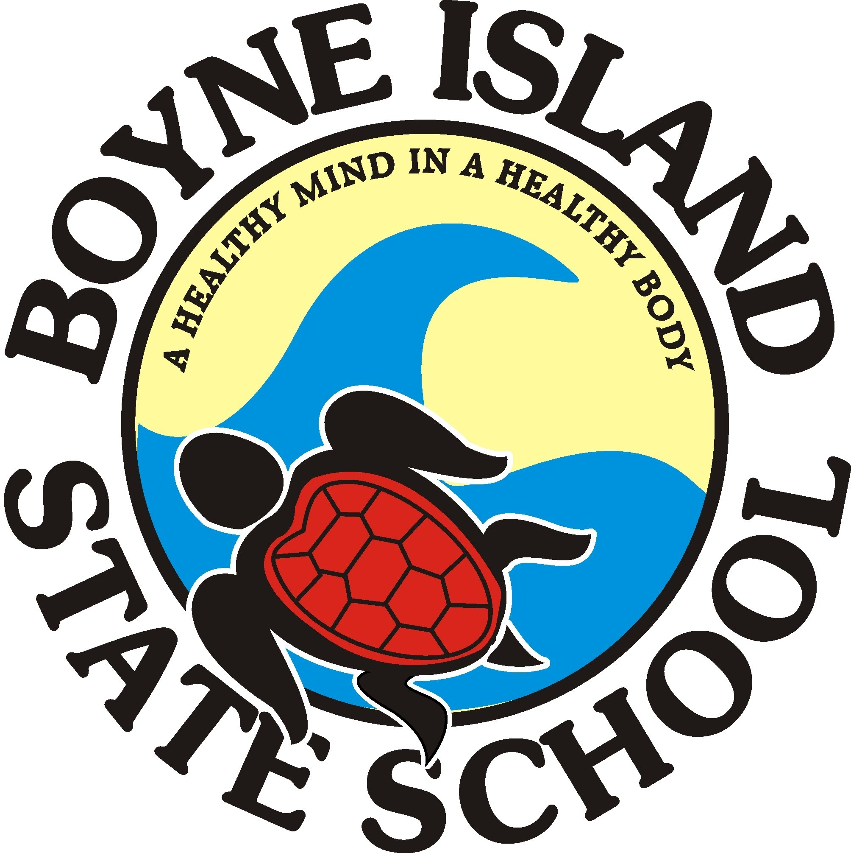 | BOYNE ISLAND STATE SCHOOL  Enrolment Agreement | 

This enrolment agreement sets out the responsibilities of the student, parents or carers and the school staff about the education of students enrolled at Boyne Island State School.

Responsibility of student to:
- attend school regularly, on time, ready to learn and take part in school activities
- act at all times with respect and show tolerance towards other students and staff
- work hard and comply with requests or directions from the teacher and principal
- abide by school rules, meet homework requirements and wear school’s uniform
- respect the school environment.

Responsibility of parents to:
- attend any open evenings organised for parents
- let the school know if there are any problems that may affect my child’s ability to learn
- inform school of reason for any absence
- treat school staff with respect and tolerance
- support the authority and discipline of the school enabling my child to achieve maturity, self discipline and self control
- abide by school’s policy regarding access to school grounds before, during and after school hours.

Responsibility of school to:
- develop each individual student’s talent as fully as possible
- inform parents and carers regularly about how their children are progressing
- inform students, parents and carers about what the teachers aim to teach the students each term
- teach effectively and to set the highest standards in work and behaviour
- take reasonable steps to ensure the safety, happiness and self-confidence of all students
- be open and welcoming at all reasonable times and offer opportunities for parents and carers to become involved in the school community
- clearly articulate the school’s expectations regarding the responsible behaviour plan for students and the school’s dress code policy
- ensure that the parent is aware of the school’s record-keeping policy including the creation of a transfer note should the student enrol at another school
- set, mark and monitor homework regularly in keeping with the school’s homework policy
- contact parents and carers as soon as is possible if the school is concerned about the child’s school work, behaviour, attendance or punctuality
- deal with complaints in an open, fair and transparent manner
- consult parents on any major issues affecting students
- treat students and parents with respect and tolerance.

I accept the rules and regulations of the Boyne Island State School as stated in the school policies that have been provided to me as follows:
- Responsible Behaviour Plan for Students {must be provided to parent}
- Student Dress Code {must be provided to parent}
- Homework Policy
- Parent Handbook of Information including;
- School Charges and voluntary contributions including Pre-payment options and P&C Levy
- Student usage of internet, intranet and extranet
- Absences
- School Excursions
- Complaints management
- Parent Notice for Religious Instruction in School Hours
- Consent to use Copyright Material, Image, Recording or Name
- Appropriate Use of Mobile Telephones and other Electronic Equipment by Students

I acknowledge that information about the school’s current programs and services has been explained to me.

Student Signature: Parent/Carer Signature: On behalf of Boyne Island State School

…………………………..… …………………………..… …………………………………………..…

Student Name: Class: Date:

…………………………..… …………………………..… _____/_____/_____

